**Section 5 - Future Development**

**5.1 Range Extender**

The future of the rotary engine has already been mentioned to be implemented as a small engine for electric vehicles. The Mazda MX-30 is an SUV currently estimated to be released in 2022 in Australia which features a small rotary engine working beside an electric motor extending mileage. The rotary engine being used as a drive or mechanism that ideally powers wheel spin is no longer a viable option in the world of car manufacturing. The rotary engine within the MX-30 works rather as a compact generator to extend battery life. Therefore, drivers can travel further. It is estimated the base range is currently approximately 200km however, this is a figure not accounting for the smaller rotary generator.

The rotary range extender will still require a small amount of fuel to operate. Furthermore, the use of a rotary engine in this manner appeals to a changing market for both the industry and consumers. A hybrid design as such would appeal to early adopters and trendsetters concerned with a growing Climate Change Emergency. Therefore, the rotary continues to impact society, simply with a changed concentration from power and performance to sustainability and economical ability.

This cars model target market, being those interested in technology and their environmental impact highlights the future for the rotary and the path it is seeming to take. Hence, it is this population that the rotary is now aimed for and will seemingly appeal to.

"It will still have a very impressive CO2 number and very much an eye to improving [Mazda's] carbon footprint and sustainable motoring into the future.” - Alastair Doak, (Mazda Australia Marketing & Product Director)

(Guthrie, 2021)

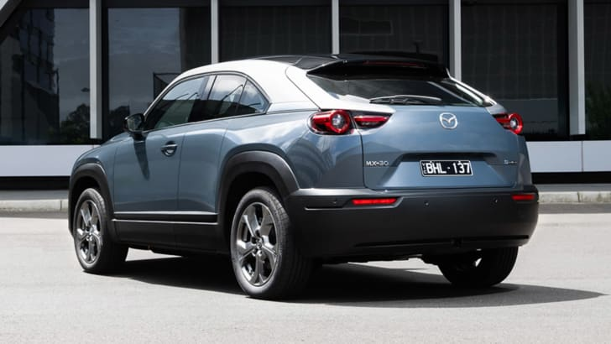

*Figure 1 - The Full-Electric MX-30*

[*Image Source*](https://www.caradvice.com.au/936107/2021-mazda-mx-30-electric-model-with-rotary-range-extender-likely-for-australia/)

Mazda has in fact done this in the past with the 2013 Mazda 2 hatch prototype which had an electric motor and a rotary range extender.

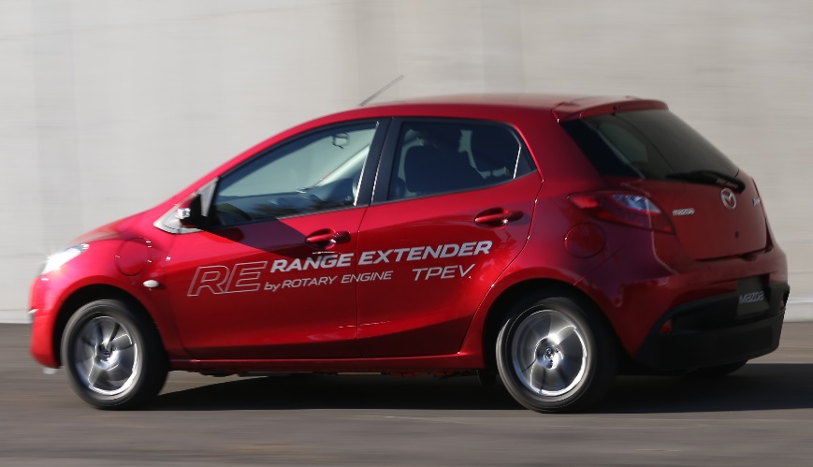

*Figure 2 - Mazda 2 EV Rotary Range Extender Vehicle*

[*Image Source*](https://www.caradvice.com.au/261593/mazda-2-ev-rotary-range-extender-review-quick-drive/)

The Mazda 2 EV also displayed (similar to other rotary vehicles) an engine helping with size and also reducing vibrations due to its piston-less property.

The rotary range extender sits under the boot floor, is compact and comprises of a nine-litre fuel tank and generator (Mazda 2 EV). Therefore, this design choice allows for no major loss to the boot compartment.

The benefits of this design is instantaneous and smooth acceleration. The regular Mazda 2 EV weighs about 150kg and hence, this generator the range extender adds another 100 kilograms. (Spinks, 2013)

The disadvantage currently with this design is that the generator has a low hum which may be disruptive to passengers or the driver.

**5.2 Future Applications**

Mazda states that the rotary generator has "great potential" in other applications and roles. The rotary generator can act as a portable power generator for the use in emergency shelters, homes, shops or on camping trips, for example.

However, for the enthusiasts, we all hope that maybe one day Mazda will release a future rotary engine vehicle sending power to the wheels.

**References:**

[1] - Guthrie, S., 2021. *2021 Mazda MX-30: Electric model with rotary range-extender likely for Australia | CarAdvice*. [online] CarAdvice.com. Available at: <https://www.caradvice.com.au/936107/2021-mazda-mx-30-electric-model-with-rotary-range-extender-likely-for-australia/> [Accessed 13 May 2021].

[2] - Spinks, J., 2013. *Mazda 2 EV Rotary Range Extender Review: Quick Drive | CarAdvice*. [online] CarAdvice.com. Available at: <https://www.caradvice.com.au/261593/mazda-2-ev-rotary-range-extender-review-quick-drive/> [Accessed 13 May 2021].